AGENDA OF THE CONFERENCE
April 21, 2016
08⁰⁰−10⁰⁰ – arrival, check-in, introduction into research developments of the Myronivka Institute;
10⁰⁰−10²⁰– opening the Conference;
10²⁰-12⁰⁰– plenary session;
12⁰⁰-13⁰⁰– coffee-break (dinner);
13⁰⁰-15⁰⁰– plenary session continued;
15⁰⁰-16⁰⁰– summing-up,
awarding the participants;
16⁰⁰ – check-out.

Transport connection
- from the Railway Station or Bus Station of Mironivka by short-bus No.3 to the Tsentralne stop;

ORGANIZING COMMITTEE OF CONFERENCE
Oleksandr Demydov, corresponding member of NAAS, director of The V.M. Remeslo Myronivka institute of wheat
Serhii Melnyk, Doctor of Economical sciences, Professor, director of The Ukrainian Institute for Plant Variety Examination
Volodymyr Gudzenko, PhD in agricultural sciences, deputy director of The V.M. Remeslo Myronivka institute of wheat
Oleksasndr Gumeniuk, PhD in agricultural sciences, head of Young Scientists Council of The V.M. Remeslo Myronivka institute of wheat
Larysa Prysiazhniuk, PhD in agricultural sciences, head of Young Scientists Council of The Ukrainian Institute for Plant Variety Examination
Olha Barban, secretary of Young Scientists Council of The Ukrainian Institute for Plant Variety Examination
Mariia Brovkina, member of Young Scientists Council of The Ukrainian Institute for Plant Variety Examination


THE V.M. REMESLO MYRONIVKA INSTITUTE OF WHEAT
NATIONAL ACADEMY OF AGRARIAN SCIENCEs OF UKRAINE

UKRAINE 08853, Kyiv region, Myronivka district, village of Tsentralne,
Tel.: +38 (04574) 74-1-35;
Tel./fax: +38 (04574) 74-4-46;
e-mail: mwheats@ukr.net,

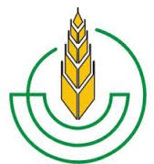
Ukrainian Institute for Plant Variety Examination

15 Henerala Rodimtseva St.
03041, Kyiv, Ukraine
Tel.: +38 044 258-34-56;
Tel./fax: +38 044 257-99-63
Е-mail: sops@sops.gov.ua

The Organizing Committee is inviting every young scientist, experts of research entities and institutions of higher learning engaged into the development of modern science to participate actively in the work of the Conference.

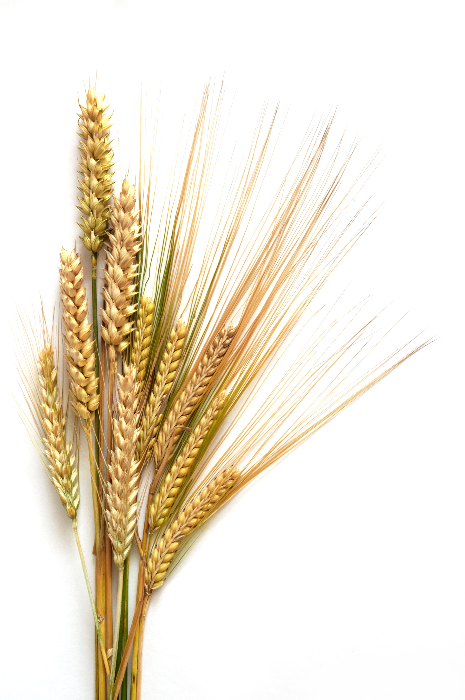
Ministry of Agrarian Policy and Food of Ukraine

The National Academy of Agrarian Sciences of Ukraine

The V.M. Remeslo Myronivka Institute of Wheat

Ukrainian Institute for Plant Variety Examination

Information letter

VII Applied science international conference of young scientists and experts

"BREEDING, GENETICS AND GROWING TECHNOLOGY FOR AGRICULTURAL CROPS"

April 19, 2019.
village of Tsentralne, Kyiv region, Ukraine
DEAR COLLEAGUES,
the Council of Young Scientists
We would like to invite you to participate in the VII Applied Science International Conference of Young Scientists and Experts on
«BREEDING, GENETICS AND GROWING TECHNOLOGY FOR AGRICULTURAL CROPS»

Data and location of the event
April 19, 2019 at the V.M. Remeslo Myronivka Institute of Wheat: UKRAINE, Kyiv region, Myronivka district, village of Tsentralne, events hall of the administrative building

Purpose of the Conference
- determining current trends of the agrarian science development;
- sharing the research developments among the young scientists of Ukraine and neighbouring countries.

THE CONFERENCE TARGETS
- Breeding and Seed Production
- Genetics and Physiology of Plants
- Biotechnology
- Plant Protection
- Plant Production and Arable Farming, Feed Production
- Horticulture, Orcharding
- Mechanization of agrarian production
- Economics of agrarian production
- Opinions of the young scientists on the development of modern agrarian science
Working languages of the Conference:
Ukrainian, English, Russian

Equipment:
multimedia projector
To apply for the participation in the Conference
Please send by March 25, 2019, at the latest
to the Organizational Committee by electronic means the following:
- Application for Participation in the Conference;
- Theses materials.

The publication is free of charge.

Prior to opening the Conference the Collection of Papers is to be published, which will be made available for the participants during the Conference.
The contributors are encouraged to submit their articles associated with subject matter of their theses. Where the articles comply with the requirements, they are to be published in the Plant Variety Studying and Rights Protection for Plant Varieties Academic and Research Journal (http://journal.sops.gov.ua/) and The Mironivka Newsteller (www.mip.com.ua)

Application for Participation in the Conference
Full name_________________________
Academic degree ____________________
Academic title ________________________
Position _____________________________
Organization you represent__________________
Contact phone ________________________
E-mail ______________________________
Name of your Report (Thesis) ___________
Would you like to book a hotel?
Yes_______ No________
I am going to (please underline as appropriate)
- to deliver a report (up to 10 min)
- publish Theses only
Please send your Application for Participation in the Conference to myronivka_konf@ukr.net, the files attached to be designated with the surname of the first author. Examples of due file naming follows: Smith_Zayavka, Smith_Tezy.
REQUIREMENTS TO FILING YOUR THESES

The materials eligible for publication are Microsoft Word documents, 1 full page without tables, graphics, pictures, references ( А-4 sheet (210×297 mm), margined as follows: upper, lower and right – 1.5 cm, left – 2 cm, Times New Roman font of type, 14 pt point size 14 pt, single spacing, 1.25 cm first line indent).

Thesis layout:
● UDC index;
● the author(s) surname(s) and initials, academic degree, academic title, position;
● name of the organisation of employment for the author;
● e-mail;
● theses name;
● body of the theses should briefly highlight the relevance of the topic, the purpose of the work (delivery of the problem), materials and methods of research, the results of the research, conclusions (or objective/problem, which is put forward for further resolution) are substantiated.
Example of arrangement follows:
UDC 63316631529
Gumeniuk, O. V., ph.D of Agriculture, Head of the Winter Whweat Breeding Laboratory, the V.M. Remeslo Myronivka Institute of Wheat, NAAS Ремесла НААН
E-mail: alexgymenyk@ukr.net

BREEDING OF WHINTER WHEAT AT FOREST-STEPPE OF UKRAINE

Breeding of wheat depending on cultivation area requires....

The author is responsible for the contents. The Organisation Committe reserves the right to reject submitted materials, which do not meet the requirements.

